From Unstructured Chaos to Queryable Knowledge: Designing Ontology-Backed Knowledge Graphs for Agentic Applications



Dhilip Kumar
Follow
9 min read
·
6 days ago
34
1

Introduction
If you’re building an agentic application, at some point you’ll hit the same wall: your agent needs to reason over a pile of unstructured information — PDFs, wikis, transcripts, tickets, contracts — and a vector store alone doesn’t cut it. Semantic search is great at finding similar text. It’s much weaker at answering questions like “who founded companies headquartered in Cupertino before 1980” — questions that require structure, not just similarity.
That’s where knowledge graphs come in. But a knowledge graph is only as useful as the schema behind it. Nodes and edges without a schema are just a pile of triples with no way to validate, infer, or query consistently. That schema is called an ontology, and the order in which you build your ontology and your graph — and how you keep both current as new data arrives — is the difference between a knowledge base that stays useful and one that quietly rots into noise.
This post walks through a practical pattern for building this system when you’re starting from a genuinely unfamiliar domain: you don’t know your entity types yet, you don’t know your relationships yet, and forcing a schema on day one would just be guessing. We’ll cover:
- Why “discover, then formalize” beats “schema-first” when the domain is unknown
- What an ontology actually is, versus what a knowledge graph instance is (with a worked example)
- The AI-native steps that bridge unstructured vectors to a structured graph
- The two loops that keep the whole system alive: the build loop and the query loop

Why not schema-first?
Traditional knowledge engineering says: define your ontology first, then extract data to fit it. That works when you already understand the domain.In my Previous Article I have mentioned that Sematic Interoperability for Data Product , that is for known domain. It falls apart when you don’t — you end up either guessing at a schema that doesn’t match reality, or spending weeks in workshops with domain experts before writing a single line of extraction code.
The alternative — increasingly practical because of LLMs — is discover-then-formalize:
- Explore the unstructured corpus first, using vector search, so a human can get a feel for the domain
- Let an LLM do open, schema-free extraction to surface candidate entities and relationships
- Induce a starter ontology from those candidates (cluster near-duplicate labels, normalize types, human approves)
- Re-run extraction against that seed ontology to build a properly typed graph
- Keep both the ontology and the graph evolving as new data arrives, instead of treating either as “done”
This isn’t a rejection of ontology-first design — it’s a recognition that with LLMs in the loop, you can earn the ontology from real data instead of authoring it from assumptions.

Ontology vs. knowledge graph: getting the layers right
A common point of confusion: are nodes and edges the same thing as classes and relationships? Not quite. They’re two different layers.
The ontology (schema / TBox) defines:
- Classes — the types of things that can exist (Organization, Person, Location)
- Subclass hierarchies — Company is a subclass of Organization
- Relationship types — headquartered_in, founded_by, with domain and range constraints
- Datatype properties — attributes like founded_year, which point to literal values, not other nodes
The knowledge graph (instance data / ABox) is the actual facts:
- Nodes — instances of a class (Apple is an instance of Company)
- Edges — instances of a relationship type (Apple —headquartered_in→ Cupertino)
- Literals — attribute values with no independent identity (1976, attached to Apple via founded_year)
That third category — literals — is worth calling out because it’s the most common mistake in extraction pipelines. A literal has no identity and nothing else ever points to it. An entity like Tim Cook, by contrast, does have identity — he could later connect to other facts (other roles, other organizations), so he should become a node, not a flattened attribute.

Worked example
Ontology:
Press enter or click to view image in full size
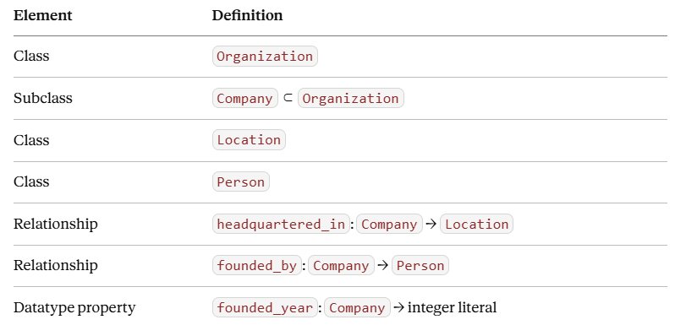
Ontology
Knowledge graph instance:
Press enter or click to view image in full size
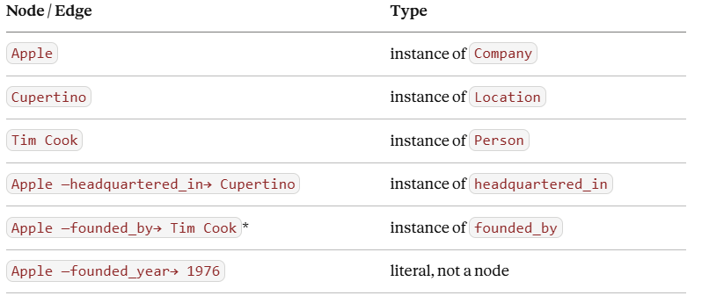
Ontology
(Simplified for the example — Apple was actually founded by Steve Jobs, Steve Wozniak, and Ronald Wayne. The point here is structural, not historical accuracy.)
The ontology says such a relationship could exist between a Company and a Location; the graph asserts that it does, specifically for Apple. That's the whole relationship between the two layers in one sentence.
The ontology, as a schema:
Press enter or click to view image in full size
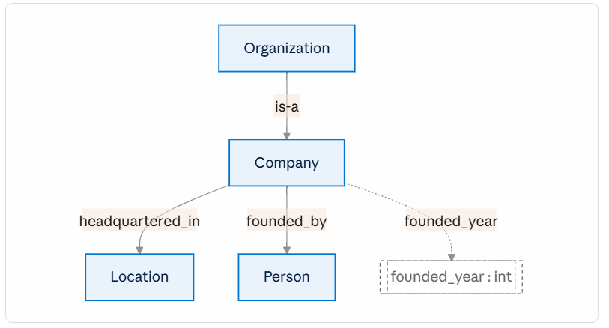
The knowledge graph, as instance data of that schema:
Press enter or click to view image in full size
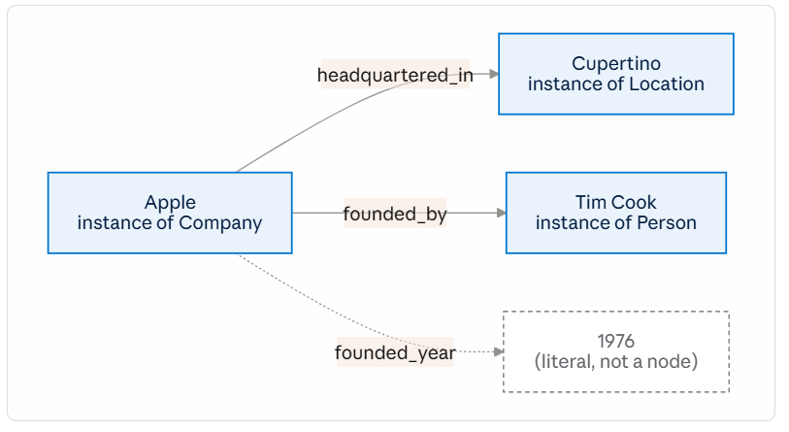
Notice the 1976 node in the diagram is styled differently on purpose — it's drawn as a box because Mermaid needs something to point an arrow at, but conceptually it isn't part of the graph's node set the way Apple, Cupertino, and Tim Cook are. It has no identity and nothing else will ever point to it.

The AI-native bridge: turning exploration into a schema
The gap in a pure “explore, then build ontology” plan is how human exploration of vectors turns into structured types. Semantic search surfaces similar passages — it doesn’t automatically surface “I need a Contract class and a governed_by relationship." You need an explicit step in between:
- Ingest and chunk the unstructured sources
- Embed into a vector store — this becomes the exploration substrate
- Human exploration — a subject-matter expert queries and browses semantically, gets a feel for what matters
- Schema-free (open) extraction — an LLM pass extracts candidate entities and relationships with no fixed schema, tagging anything unfamiliar rather than discarding it or forcing a bad fit
- Ontology induction — cluster and normalize the candidate labels (embedding similarity plus LLM-assisted merging) so “Apple Inc,” “Apple,” and “AAPL” collapse into one entity, and near-duplicate relation labels collapse into one predicate. A human reviews and approves this as the seed ontology.
- Re-run extraction against the seed ontology, now producing properly typed nodes and edges
Laid out as a sequence, the actors involved and the order they talk to each other looks like this:
Press enter or click to view image in full size
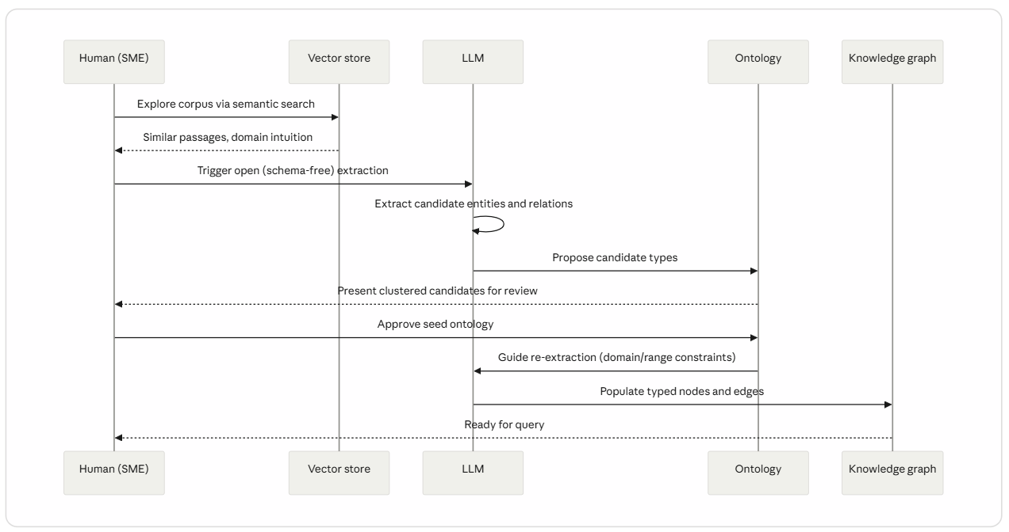
From here, the two ongoing loops take over.

Loop one: the build loop
This loop never really finishes — it just slows down as the domain model matures.
Unstructured data splits into two parallel paths:
- Vector store path — chunk and embed for semantic search
- Extraction path — LLM extraction, constrained (or guided) by the current ontology, producing candidate triples
Extracted candidates go to human review, which does two things: approves valid nodes/edges into the ontology and knowledge graph store, and — critically — feeds back to update the ontology itself when something genuinely new shows up (a new class, a new relationship type). That updated ontology then guides the next extraction pass. It’s a loop, not a pipeline stage.
There are two extraction modes worth knowing:
- Closed/constrained extraction — the LLM only extracts instances of classes and relations already in the ontology. Use this once the ontology is fairly stable.
- Open extraction with ontology as guidance — the LLM proposes new candidate types when the text doesn’t fit anything defined yet, tagged separately rather than dropped or force-fit. Use this early on, or during periodic re-audits.
A useful discipline: run a conformance check after every extraction pass — does every triple’s subject/object type actually match its relation’s declared domain and range? LLMs do occasionally hallucinate relation types near ontology boundaries; catching that automatically, before it reaches human review, saves a lot of reviewer time.
Both paths converge into a hybrid retrieval layer — vector store plus ontology-backed graph — which is what the query loop actually talks to.
Press enter or click to view image in full size
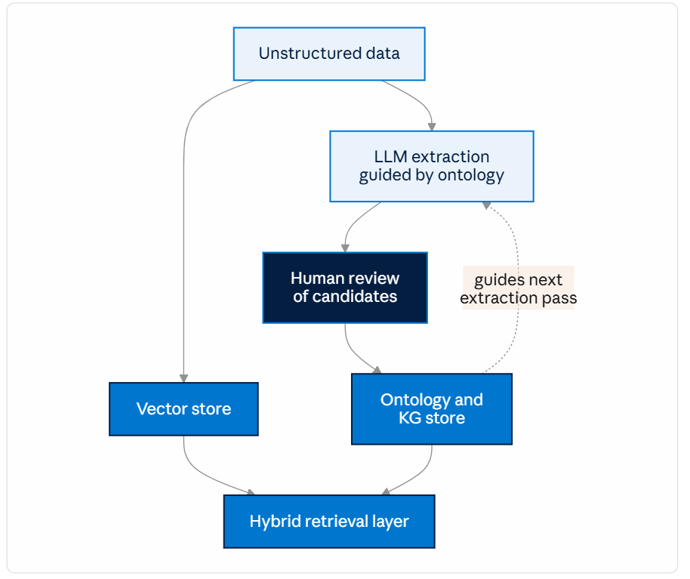
This loop has no natural end state. It keeps running — just less frequently — for as long as new documents keep arriving.

Loop two: the query loop
Every query — from an agent or a human — runs through this loop:
- Query arrives
- Ontology interprets and plans — it doesn’t hold the answer, it holds the map. For “who founded Apple?”, the ontology tells the planner: founded_by exists, domain is Company, range is Person, so look for a Company node matching "Apple" and traverse that edge. This is also where disambiguation happens — if "Apple" could mean the company or something else in your domain, the ontology's type system is what lets the agent ask a sharp clarifying question instead of guessing.
- Split into two retrieval paths:
- Graph traversal for precise, structured, multi-hop facts
- Vector search for fuzzy, narrative, or free-text context
4. Combine and assemble the answer from both
5. Human review — added conditionally, for ambiguous or high-stakes queries only
The two human-in-the-loop points in this whole system are doing genuinely different jobs, and it’s worth being explicit about which one you mean when you say “HITL”: build-time review is about the correctness of the schema and the data; query-time review is about disambiguation and risk on a specific answer. Conflating them tends to produce a review UI that’s mediocre at both.
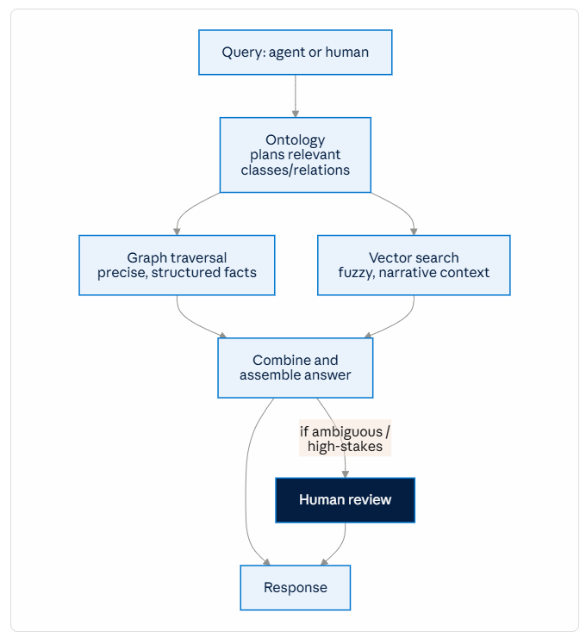
This is the consumption pipeline — the part of the system every agent or user-facing query actually runs through, on every request, regardless of what stage the build loop happens to be in.

Putting it together
The full lifecycle, end to end:
Press enter or click to view image in full size
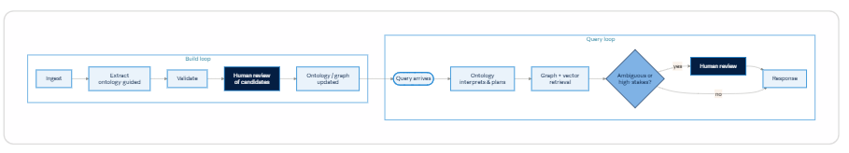
The build loop runs continuously in the background, growing slower in cadence as your ontology matures. The query loop runs on every single request, and it’s only as good as whatever state the build loop has produced so far. Neither one is ever “done” — and treating either as a one-time setup step is the most common way these systems degrade over time.

What’s not covered here (and probably should be, next)
This post focused on the design pattern. A few things worth a follow-up if you’re taking this to production:
- Ontology versioning and migration — how to evolve class/relationship definitions without breaking already-extracted data
- Conflict resolution — what happens when two documents assert contradictory facts about the same entity
- Evaluation metrics — how do you actually measure extraction quality and ontology coverage over time, not just eyeball it
- Access control and multi-tenancy — if different consumers should see different slices of the graph
- Tooling choices — graph database options (e.g., property graph vs. RDF/OWL stores), and where GraphRAG-style frameworks fit in versus building this extraction/review loop yourself
- Cost and latency tradeoffs — LLM extraction and re-extraction at scale isn’t free; when to batch vs. stream

Conclusion
The instinct that started this whole discussion — “I don’t know my domain yet, so let me explore first” — turns out to be the right one, as long as it’s paired with a mechanism to turn that exploration into structure. Vectors alone give you similarity, not truth; a knowledge graph without an ontology is just an unconstrained pile of triples wearing a fancier name. The ontology is what turns raw extraction into something an agent can trust, validate, and traverse with confidence.
The bigger shift, though, is realizing this isn’t a project with a finish line. It’s two loops running at different tempos: a build loop that keeps refining the schema and the graph as new documents arrive, and a query loop that leans on whatever state the build loop has produced at that moment — no more, no less. Treat either one as a one-time setup task, and the system quietly drifts out of sync with reality. Treat both as ongoing, and you end up with a knowledge base an agent can actually reason over, not just search.
If you’re building this for a real agentic application, start small: pick one narrow slice of your corpus, run it through the discover-then-formalize sequence end to end, and let the seed ontology be genuinely rough. It’s much easier to extend a small, honest ontology than to unwind a large, wrong one.

